A Mini Project Report

On

**FAKE NEWS DETECTION**

*Submitted to* ***KL University Hyderabad*** *for the Partial fulfilment of the requirement for the Award of Degree in*

**BACHELOR OF TECHNOLOGY**

in

**COMPUTER SCIENCE & ENGINEERING**

Submitted by

G. Srihari (190339321)

K. Charan Sai (190330098)

G. Pavan Kalyan (190330275)

Ch. Sushant (190330271)

Under the Esteemed Guidance of

**Mrs. Arpita Gupta**

**(Associate Professor)**

**(CSE Dept)**

**CERTIFICATE**

This is to certify that the Mini Project Report entitled **“FAKE NEWS DETECTION”** is being submitted by **G. Srihari (190339321), K. Charan Sai (190330098), G. Pavan Kalyan (190330275), Ch. Sushant (190330271)** in partial fulfilment of the requirements for the award of the Degree of **Bachelor of Technology** in **Computer Science & Engineering,** to the **KL University Hyderabad**, during academic year 2020-2021, is a bonafide work carried out by them under my guidance and supervision.

The results presented in this Project Work have been verified and are found to be satisfactory. The results embodied in this Project Work have not been submitted to any other University for the award of any other degree or diploma.

|  |  |
| --- | --- |
| **Project Guide** | **Head of the Department** |
| Mrs. Arpita Gupta | Mr. Dr. Chiranjeevi Manike |
| Associate Professor | Associate Professor |
| Dept. of CSE | Dept. of CSE |

**ACKNOWLEDGEMENT**

We would like to express our sincere gratitude to our advisor, **Mrs. ARPITA GUPTA, Associate Professor**, **CSE Dept.**, whose knowledge and guidance has motivated us to achieve goals we never thought possible. The time we have spent working under his supervision has truly been a pleasure.

The experience from this kind of work is great and will be useful to us in future. We thank **Dr. CHIRANJEEVI MANIKE, Associate Professor& HOD**, CSE Department, for encouraging us to do such research work and for providing all the facilities to carry out this project work.

It is a great pleasure to convey our thanks to our principal **Dr. KOTESHWAR RAO,** Principal of KL University and the College Management for permitting us to undertake this project and providing excellent facilities to carry out our project work.

We thank all the **Faculty** members of the Department of Computer Science & Engineering for sharing their valuable knowledge with us. We extend our thanks to the **Technical Staff** of the department for their valuable suggestion to technical problems.

Finally Special thanks to our parents for their support and encouragement throughout our life and this course. Thanks to all our friends and well-wishers for their constant support.

**DECLARATION**

We hereby declare that the work which is being presented in this dissertation entitled, “**FAKE NEWS DETECTION”,** submitted towards the partial fulfilment of the requirements for the award of the degree of **Bachelor of Technology** in **Computer Science & Engineering**, **KL University Hyderabad,** is an authentic record of our own work carried out under the supervision of **Mrs. ARPITA GUPTA, Associate professor, Department of CSE.**

To the best of our knowledge and belief, this project bears no resemblance with any report submitted to any other University for the award of any degree or diploma.

**G. SRIHARI (190339321)**

**K. CHARAN SAI (190330098)**

**G. PAVAN KALYAN (190330275)**

**CH. SUSHANT (190330271)**

Date:

Place: HYDERABAD

.

**ABSTRACT**

Fake news has immense impact in our modern society. Detecting Fake news is an important step. The main aim is to detect the Fake News using machine learning techniques. Machine Learning algorithms such as Logistic Regression and Decision Tree Classifier have using used on different datasets acquired from various sources. Initial step is to clean the data before using the machine learning method to classify data. The result show that Logistic Regression to detect Fake news has accuracy 98.82%. Two other more advance methods which are Decision Tree and Random Forest achieve the accuracy of 99.65% and 99.21%.

**Table of Contents**

**PAGENO**

**LIST OF TABLES i**

**LIST OF FIGURES ii**

**1. INTRODUCTION 1-3**

1.1 Motivation 1

1.2 Existing System 1

1.3 Problem Statement 2

1.4 Proposed System 2

1.4.1 Objective 3

1. **LITERATURE SURVEY 4-6**
2. **REQUIREMENTS & DOMAIN INFORMATION 7-8**
   1. Requirement Specifications 7
      1. Hardware Requirements 7
      2. Software Requirements 7
   2. Domain Information 7-8
3. **EXPERIMENTAL ANALYSIS 9-14**
   1. Architecture of Proposed System 9
   2. System Design 10
      1. Data Flow Diagrams 10-12
   3. Testing 13-14
4. **OUTPUT SCREENS 15-23**
   1. Screen Shots 23
5. **CONCLUSION AND FUTURE SCOPE 24**
   1. Conclusion 24
   2. Future Scope 24

**REFERENCES 25**

**1.INTRODUCTION**

Fake News Detection emphasises on providing solutions to the community by providing a reliable platform to check the Authencity of news. Fake News Detection using Machine Learning revolves around discovering the probability of a news being fake or real. Fake news might be a moderately new term yet it isn't really another new phenomenon. However, the advances in technology and the spread of news through various kinds of media have expanded the fake news expansion today. As such, fake news impacts have expanded exponentially in the past and something must be done to keep this from proceeding later in the future.

Fake News Detection includes using Machine Learning techniques to make a model that can uncover records that are, with high probability, fake news stories and articles.

# 1.1 Motivation

Fake News mostly spreads through the medium of social networking sites such as Facebook, Twitter and several others. Fake news is written and published with the internet to mislead in order to damage a person, and gain financially or politically. Our goal is to develop a reliable model that classifies a given news article as either fake or true.

We have taken key expressions of the news affairs in the form of data that the individual needs to verify. Data Pre-processing unit is considered to be liable for setting up data for the additional processing required. We can determine whether a news story is fake or genuine once we have considered all the classes. Also, the authenticity for a new story is given. After that we classify the outputs and use classification algorithms.

# 1.2 Existing System

There exists a large body of research on the topic of machine learning methods for deception, detection most of it has been focusing on classifying online reviews and publicly available social media posts. Particularly since late 2016 during the American Presidential election, the question of determining 'fake news' has also been the subject of particular attention within the literature.

# 1.3 Problem Statement:

The problem is to identify the authenticity of the news and online content. Equally important problem is to identify the bots involved in spreading false news. Social media for news consumption is a double-edged sword. On the one hand, its low cost, easy access, and rapid dissemination of information lead people to seek out and consume news from social media. On the other hand, it enables the wide spread of “fake news”, i.e., low quality news with intentionally false information. The extensive spread of fake news has the potential for extremely negative impacts on individuals and society. Therefore, fake news detection on social media has recently become an emerging research that is attracting tremendous attention

# 1.4 Proposed System:

A model is build based on the count vectorizer or a tfidf. Since this problem is a kind of text classification, implementing a Random Forest classifier will be test as this is standard for text-based processing. The actual goal is in developing a model which was the text transformation. Now next step is to extract the most optimal features for count vectorizer or tfidf-vectorizer, this is done by using a n-number of the most used words, and lower casting or not, mainly removing the stop words which are common words such as “the”,” when”, and “there”, and only using those words that appear at least a given number of times in a given text dataset.

The fundamental thought to make a model to foresee the trustworthiness of continuous news affairs going on. The proposed is comprises of following steps:

* Collection of Data
* Pre-Processing of Data
* Classification • Result Analysis

.

## 1.4.1 Objective:

The main objective is to detect the fake news, which is a classic text classification problem with a Straight forward proposition. It is needed to build a model between “Real” news and “Fake” news. Fake news and lack of trust in the media are growing problems with huge ramifications in society.

**2.LITERATURE SURVEY**

In Shloka Gilda presented concept approximately how NLP is relevant to stumble on fake information. They have used time period frequency-inverse record frequency (TFIDF) of bi-grams and probabilistic context free grammar (PCFG) detection. They have examined their dataset over more than one class algorithms to find out the great model. They locate that TF-IDF of bi-grams fed right into a Stochastic Gradient Descent model identifies non-credible resources with an accuracy of seventyseven.2%

In Mykhailo Granik proposed simple technique for fake news detection the usage of naive Bayes classifier. They used BuzzFeed news for getting to know and trying out the Naïve Bayes classifier. The dataset is taken from Facebook news publish and completed accuracy up to seventy-four% on test set.

In Cody Buntain advanced a method for automating fake news detection on Twitter. They applied this method to Twitter content sourced from BuzzFeed’s fake news dataset. Furthermore, leveraging non-professional, crowdsourced people instead of journalists presents a beneficial and much less costly way to classify proper and fake memories on Twitter rapidly

In Marco L. Della offered a paper which allows us to recognize how social networks and gadget studying (ML) strategies may be used for faux news detection. They have used novel ML fake news detection method and carried out this approach inside a Facebook Messenger chatbot and established it with a actual-world application, acquiring a fake information detection accuracy of eighty one.7%.

In Rishabh Kaushal carried out 3 getting to know algorithms specifically Naive Bayes, Clustering and Decision bushes on some of features such as tweet-degree and consumer-level like Followers/Fellowes, URLs, Spam Words, Replies and Hashtags.

Improvement of unsolicited mail detection is measured on the premise of general

Accuracy, Spammers Detection Accuracy and Non-Spammers Detection Accuracy.

In Saranya Krishnan used superior framework to identify faux information contents.

Initially, they've extracted content material capabilities and consumer functions via Twitter API. Then functions together with statistical analysis of twitter user accounts, reverse picture searching, verification of fake news asset is used by facts mining algorithms for class and analysis.

Jia et al. performed some simulation analysis of Network Spam Machine Learning Models, and its findings revealed that SVM exceeded the 99.4% accuracy of recall and F1 value of both the rule based and the decision tree classifiers

Kudugunta et.al. proposed a new subjective LSTM architecture that would allow them to use tweet content and metadata to identify tweet-level bots. They analysed 3000 Twitter Bots using Logistic Regression, Random Forest and AdaBoost Classifier. The suggested model accomplished an exceptionally high precision of over 99.81 percent from a single tweet using AdaBoost.

Jiawei Zhang et. al., presented the difficulties identified from the determinant factors of false information and numerous associations between news reports, authors and topics. This work proposes a new automatic model of false information legitimacy. It constructs a profoundly diffuse framework to study the interpretations of news reports, authors and topics concurrently on the basis of a collection of specific and implicit feature vectors by the textual content. False information refers to the kind of daily mail that deliberately displays misleading data or fake stories propagating by both the conventional print media and latest social networks online.

Aswini Thota et. al., evaluated the approach by utilising Deep Learning algorithms for the purpose of false information detection. The accelerating growth in the production and transmission of erroneous media introduces an instant demand for certain distorted news stories to be tagged and detected instantaneously. Accurate analysis of false information is a difficult task to achieve as it needs the method to recognise complexities in natural language. False news is a concept used by conventional news sources such as tv advertising, and also non - conventional news sources such as social networks, to reflect false news or advertising that contains misleading data. The basic purpose for propagating this information is to confuse viewers, harm some individual's reliability, or benefit from headlines.

Pallavi B. Petkaret. al., conducts a review of deep learning methods, which are primarily utilised for fake identification and are easier to produce outcomes. For many factors, identification of misleading facts is technically difficult. Information is generally produced and rapidly shared using different social networking platforms, resulting in a huge amount of data to be analysed. Internet data is quite common, covering a vast range of topics, adds difficulty to this mission. for the identification of false information coming from noncredible sites that distort actual news articles, the integration of deep learning algorithms is examined. The goal of the research is to figure out a solution that people can utilize to identify and select out pages that consist false and inaccurate information.

Steni Mol T Set. al., analysed the systematic overview of studies in current survey on the identification of false information on the internet. A huge amount of data has been exchanged on social networking websites and we are unable to distinguish as to which data is false and which is true. When they come along a message, users instantly begin communicating their complaint or voicing their viewpoint, before checking its validity. It therefore leads to its distribution. The much more common sources of incorrect and unauthorised data are false information and rumours and must be identified quickly to prevent their drastic issues. This work introduces the social networking false news identification study, which would be to determine the public view of a customer's different forums and to detect the real facts. Research focus on identification of fake news confirmed by using different strategies of computer vision and machine learning.

**3.REQUIREMENTS AND DOMAIN INFORMATION**

**3.1. Requirement Specifications**

### 3.1.1 Hardware Requirements

Processor: Pentium IV

Hard Disk:40 GB

Memory: 1 GB

### 3.1.2 Software Requirements

Operating System: Windows 10

Language Used: Python

Development Environment: Anaconda, Jupiter

Dataset: Collection of Various News Articles

IDE: Jupiter Notebook

**3.2 Domain Information**

Machine learning is the concept that a computer program can learn and adapt to new data without human intervention. Machine learning is a field of [artificial](https://www.investopedia.com/terms/a/artificial-intelligence-ai.asp) intelligence (AI) that keeps a computer’s built-in [algorithms](https://www.investopedia.com/terms/a/algorithm.asp) current regardless of changes in the worldwide economy. The term machine learning was first introduced by Arthur Samuel in 1959.

A Machine Learning system learns from historical data, builds the prediction models, and whenever it receives new data, predicts the output for it. The accuracy of predicted output depends upon the amount of data, as the huge amount of data helps to build a better model which predicts the output more accurately.

Suppose we have a complex problem, where we need to perform some predictions, so instead of writing a code for it, we just need to feed the data to generic algorithms, and with the help of these algorithms, machine builds the logic as per the data and predict the output. Machine learning has changed our way of thinking about the problem.

The need for machine learning is increasing day by day. The reason behind the need for machine learning is that it is capable of doing tasks that are too complex for a person to implement directly. As a human, we have some limitations as we cannot access the huge amount of data manually, so for this, we need some computer systems and here comes the machine learning to make things easy for us.

We can train machine learning algorithms by providing them the huge amount of data and let them explore the data, construct the models, and predict the required output automatically. The performance of the machine learning algorithm depends on the amount of data, and it can be determined by the cost function. With the help of machine learning, we can save both time and money.

Machine learning is a growing technology which enables computers to learn automatically from past data. Machine learning uses various algorithms for building mathematical models and making predictions using historical data or information**.** Currently, it is being used for various tasks such as image recognition**,** speech recognition**,** email filtering**,** Facebook auto-tagging**,** recommender syst**e**m, and many more.

**4.EXPERIMENTAL ANALYSIS**

**4.1. Architecture of Proposed System**

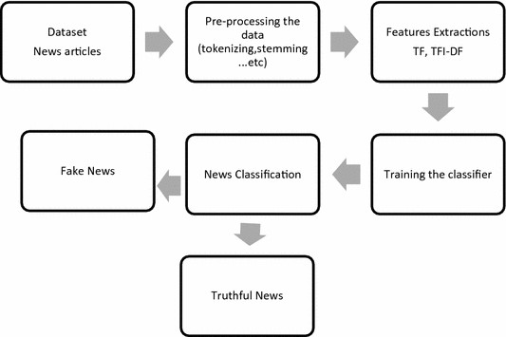

Fig:4.1 Architecture for Fake news Detection

The News articles (dataset) can be collected form Kaggle website and can be preprocessed in the next stage. Then Feature Extractions like TF, TFI-DF (Term frequency, Inverted Document Frequency) applied. Then the data will be trained and tested then classification methods such as Logistic Regression, Decision Tree classifier, Random Forest are applied then it is classified as true or false.

**4.2. System Design:**

**4.2.1 Data Flow Diagram:**

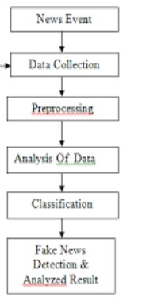

Fig:4.2.1 Data Flow Diagram For Fake News Detection

**Data Set: -** A dataset was taken from a Kaggle-based website. And the data set contains text data; it is in the form of .csv format. In this, data set consists of number of statements along with labels are true or false respectively.

**Pre-Processing: -** In this, pre-handled and to dispose of undesirable information like Stop words, copied words, clear spaces and so on. Before addressing the information using n-gram and vector-based model, the data ought to be presented to certain clarification like stop-word clearing, tokenization, a lower bundling, sentence division, and highlight ejection. This will help us with diminishing the size of real information by removing the irrelevant data that exists in the information.

**Feature Extraction:** - Text categorization is gaining from high dimensional information. There are an enormous assortment of terms, words, and expressions in records that cause a high technique trouble for the preparation procedure. In addition, insignificant and repetitive features can hurt the precision and execution of the classifiers. In this manner, it's ideal to perform feature decrease to scale back the text element estimate and maintain a strategic distance from monster include area measurement. In this, we have a tendency to study during this analysis two totally different options choice strategies, to mention, Term Frequency and Term FrequencyInverted Document Frequency.

**TF (Term Frequency):**

Total No. Of times the word has occurred in a document divided by the total no. Of words in the document is known as term frequency. High value means the word has that a term has occurred more frequently than the other terms & therefore the document file, when the term is a part of the speech is a good match.

**IDF (Inverse Document Frequency):**

Log of the no. Of documents divided by the no. Of documents that contain the word w is known as IDF or Inverse Document Frequency. The weight of less frequent words in all the documents in the corpus is determined by Inverse Document Frequency. Words occurring many times in a document and other documents as well may not be considered relevant. Significance of a term in the entire corpus is known as IDF. TfidfVectorizer coverts documents which were initially raw to TF-IDF features matrix.

**Classification:** -After feature extraction stage classification was acted right now.

Classification begins with pre-processing the informational index, by expelling superfluous characters and words from the data. The last advance in the characterization procedure is to prepare the classifier. We investigated different classifiers to predict the class of the documents. We researched various classifiers to foresee the class of the documents. We explored explicitly two distinctive machine learning calculations, to be specific,

1. **Logistic Regression:** As we are classifying text on the basis of a wide feature set, with a binary output (true/false or true article/fake article), a logistic regression (LR) model is used, since it provides the intuitive equation to classify problems into binary or multiple classes to get the best result for all individual datasets, while multiple parameters are tested before acquiring the maximum accuracies from LR model.
2. **Random Forest Classifier**: Random forest (RF) is an advanced form of decision trees (DT) which is also a supervised learning model. RF consists of large number of decision trees working individually to predict an outcome of a class where the final prediction is based on a class that received majority votes. Predictions of several trees are combined by random forest classifiers. Utilizing a subset of features, each decision tree is created. Each decision tree produces one class and eventually bootstraps the votes to obtain the better accuracy from the Random Forest technique. A tree-shaped pattern is used to describe the plan of action in decision tree. At any node, a decision will be made. The error rate is low in random forest as compared to other models, due to low correlation among trees. Our random forest model was trained using different parameters; i.e., different numbers of estimators were used in a grid search to produce the best model that can predict the outcome with high accuracy. There are multiple algorithms to decide a split in a decision tree based on the problem of regression or classification. For the classification problem, we have used the Gini index as a cost function to estimate a split in the dataset. The Gini index is calculated by subtracting the sum of the squared probabilities of each class from one.

**3.Decision Tree Classifier:** A decision tree is a set of decision nodes that start at the root. The benefits of utilizing a decision tree include easy interpretation, efficient handling of outliers, no need for the linear separation of classes, dependent features. Nevertheless, the existence of so many sparse features could lead a decision tree to overfit, and thus it performs poorly.

**Detection of Fake News:** - After, classification was done, we automatically discover the news is fake or not individually. Machine learning classification algorithms are utilized to find detection of fake news data. And also calculates the accuracy of data using classification algorithms.

**4.2. Testing:**

Machines learning is a study of applying algorithms and statistics to make the computer to learn by itself without being programmed explicitly. Computers rely on an algorithm that uses a mathematical model. This model uses a data set which is known as “Training Dataset” to learn and to predict the desired outcome. There are multiple learning algorithms that can be used to solve the problem but the concept remains the same. All these algorithms fall into two categories viz. Supervised learning or Unsupervised learning. Supervised learning output generates two types of values and is classified in to two, one is Categorical (Classification Model) where the value is from the finite set and another one is Nominal (Regression Model) where the value is a realvalued scalar. These algorithms are trained using the dataset and the outputs are predicted. In order to test a machine learning algorithm, tester defines three different datasets viz. Training dataset, validation dataset and a test dataset (a subset of training dataset). Tester first defines three datasets, training dataset, validation dataset and test dataset.

Once the evaluation of all the models is done, the best model should be taken based on the least error rate and high approximate prediction will be picked and tested with a test dataset to ensure the model still performs well and matches with validation dataset results.

Manual Testing is a type of software testing in which test cases are executed manually by a tester without using any automated tools. The purpose of Manual Testing is to identify the bugs, issues, and defects in the software application. Manual software testing is the most primitive technique of all testing types and it helps to find critical bugs in the software application.

**Accuracy:** It’s the most basic way of evaluating the learning model. It’s a ratio between the positive (TN(True Negatives) +TP(True Positives)) predictions vs the total number of predictions. If the ratio is high then the model has a high prediction rate. Accuracy that gives us the knowledge about a fraction of samples that are correctly predicted is the most commonly used metric for classification. Sklearn library is used to predict the accuracy score that will take the input as datasets and the dataset labels & predicted dataset labels are used to display the percentage of accuracy of the model.

**Confusion Matrix**: Confusion Matrix is also called as an error matrix, a confusion matrix is employed to specifically solve the matter of applied mathematics classification within the machine learning field. Essentially a confusion matrix is employed to allow the outline on however well the classification model or classifier has performed on a dataset that we all know verity values. A confusion matrix features a tabular structure. The performance of the classifier is unreal. The confusion between totally different categories is well known.

**Precision:**

It is another commonly used performance metric for classification which gives the percentage of results which are relevant i.e., it identifies relevant data points.

**Recall:**

Another performance metric used in classification modelling which is the percentage of results that are actually relevant i.e., correctly classified by the model.

**5.OUTPUT SCREENS**

**5.1 : Screenshots:**

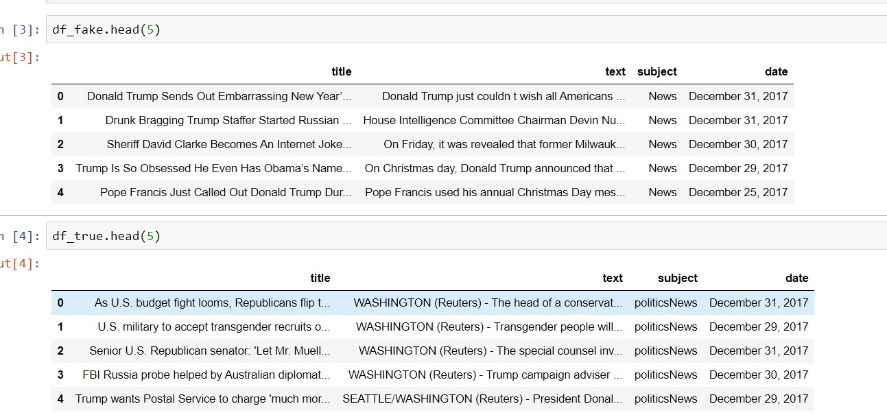

**Fig: 5.1.DataSet**

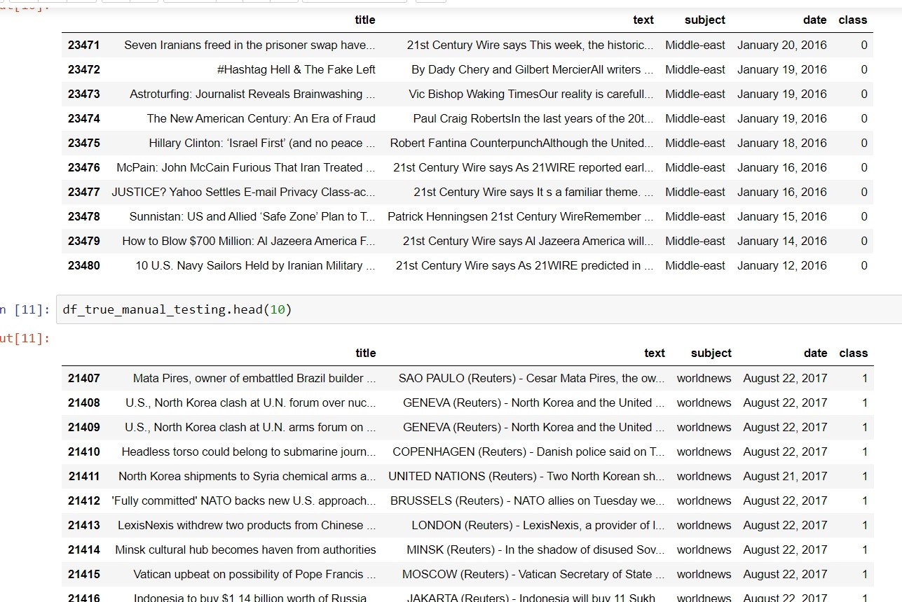

**Fig: 5.2.Manual Testing**

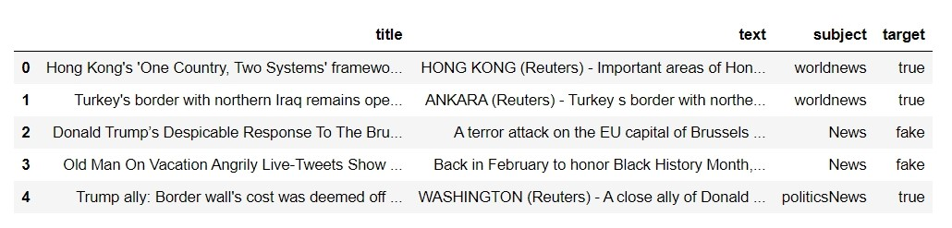

**Fig:5.3.Removing the Date**

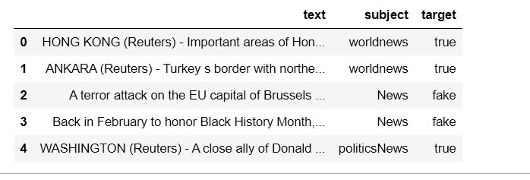

**Fig: 5.4. Removing the Title**

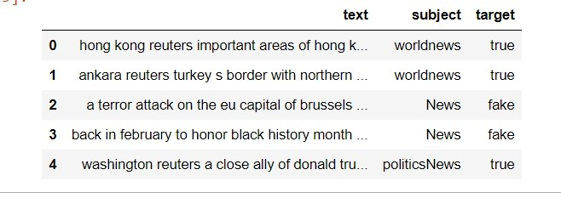

**Fig:5.5. Convert text to lower case**

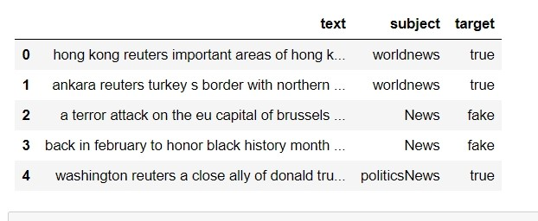

**Fig:5.6. Removing punctuation**

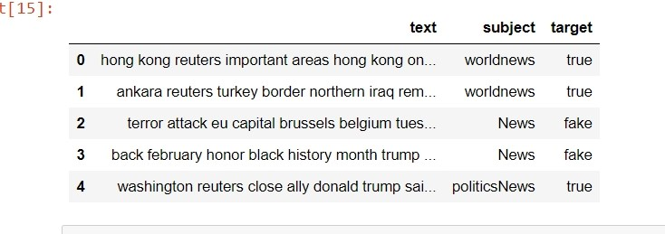

**Fig:5.7. Removing Stopwords**

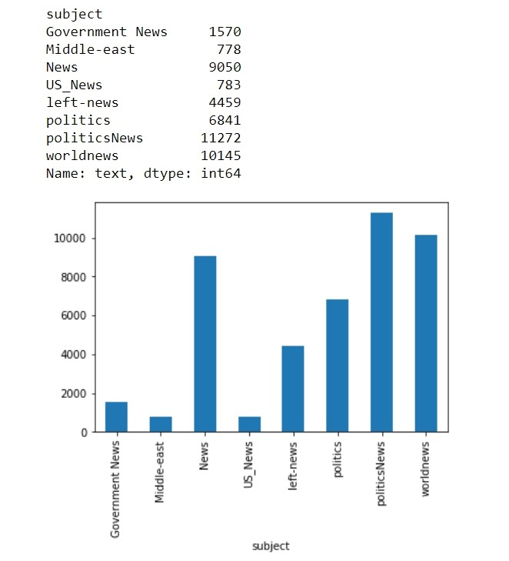

**Fig:5.8. Articles per subject**

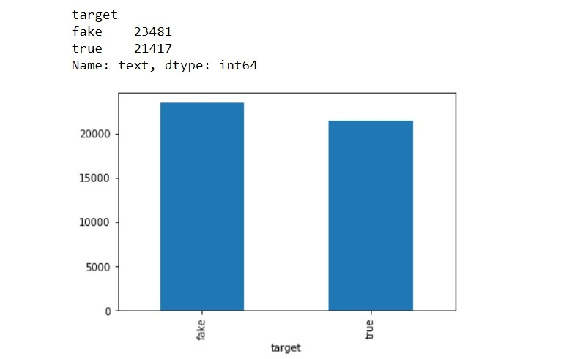

**Fig:5.9. Identifying real and fake news**

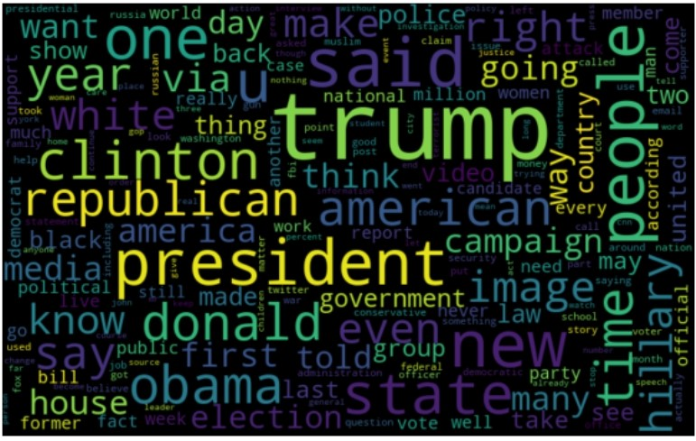

**Fig:5.10. Wordcloud for fake news**

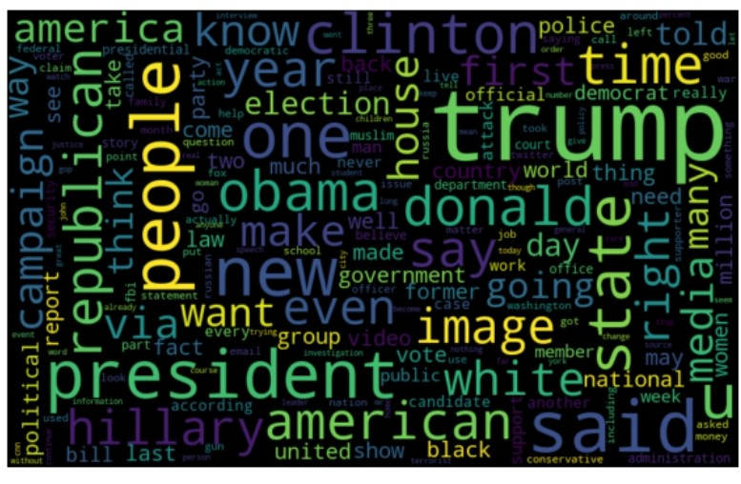

**Fig:5.11.Wordcloud for real news**

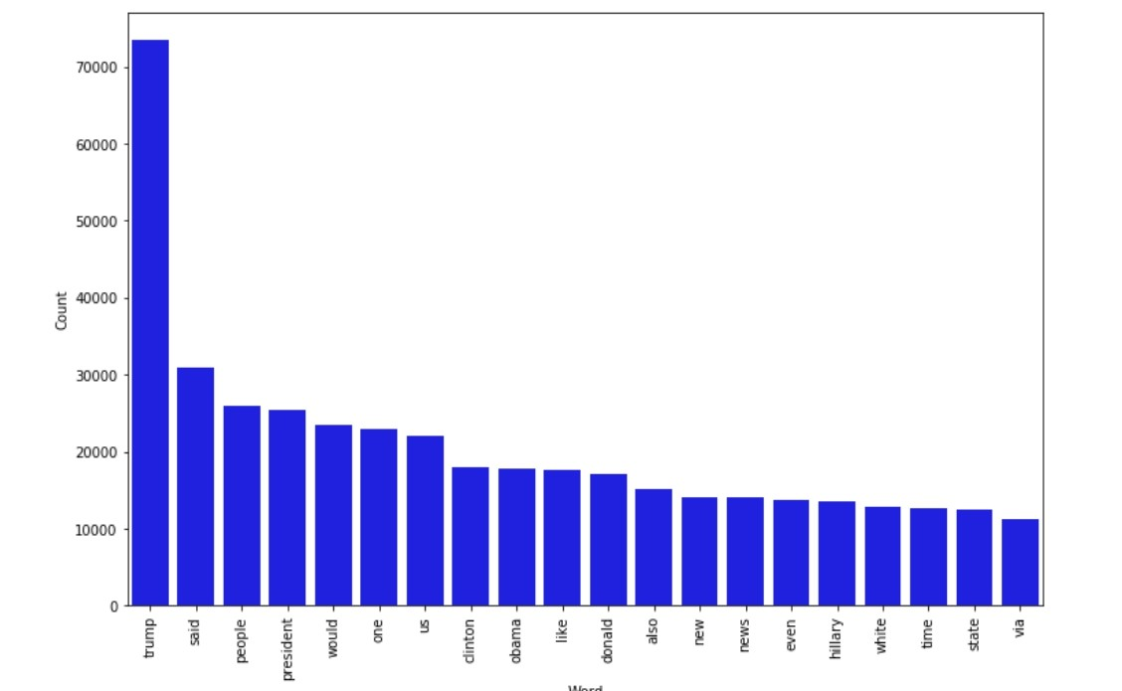

**Fig:5.12. Most frequent words in fake news**

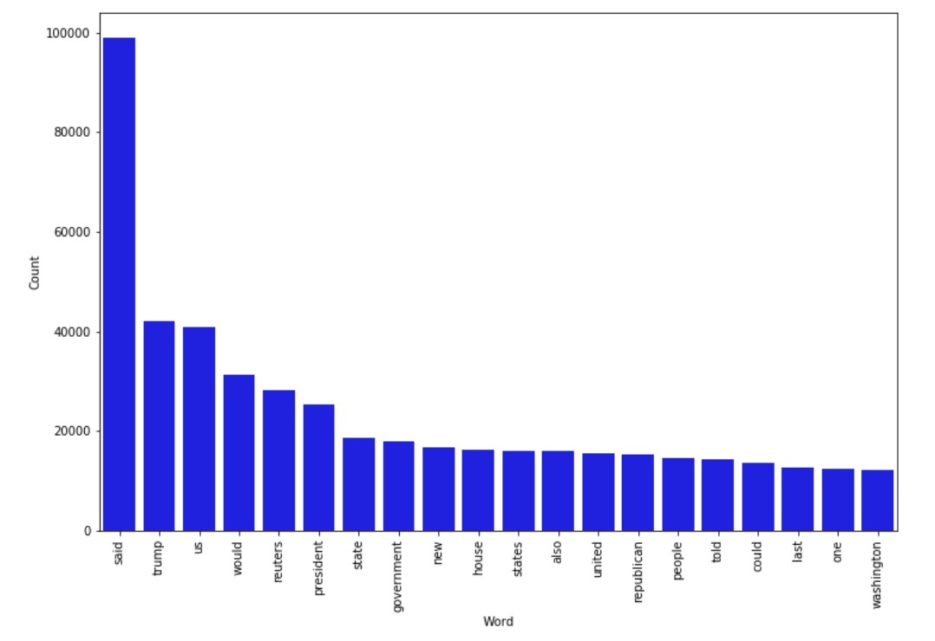

**Fig:5.13. Most frequent words in real news**

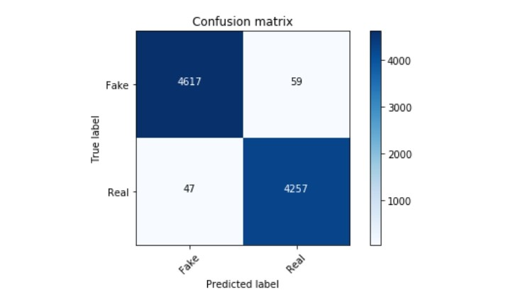

**Fig:5.14. Confusion Matrix for Logistic Regression**

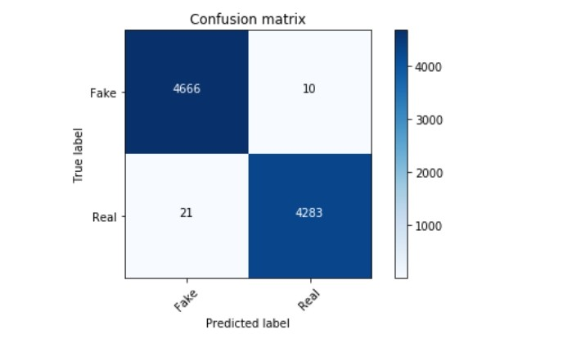

**Fig:5.15.Confusion Matrix for DecisionTree Classifier**

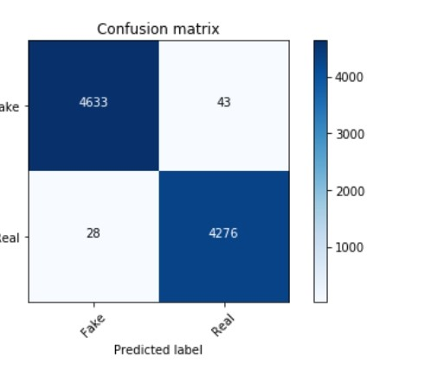

**Fig:5.16.Confusion Matrix for Random Forest Classifier**

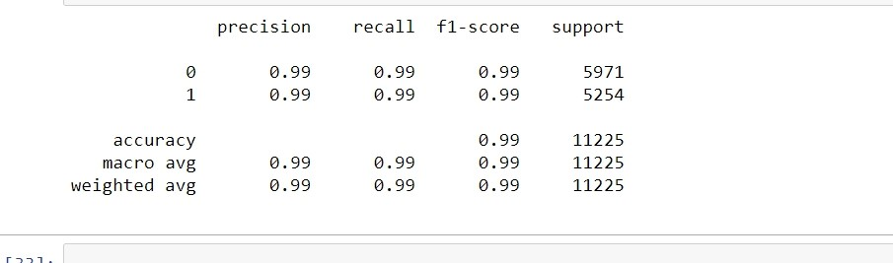

**Fig:5.17. Accuracy of Logistic Regression**

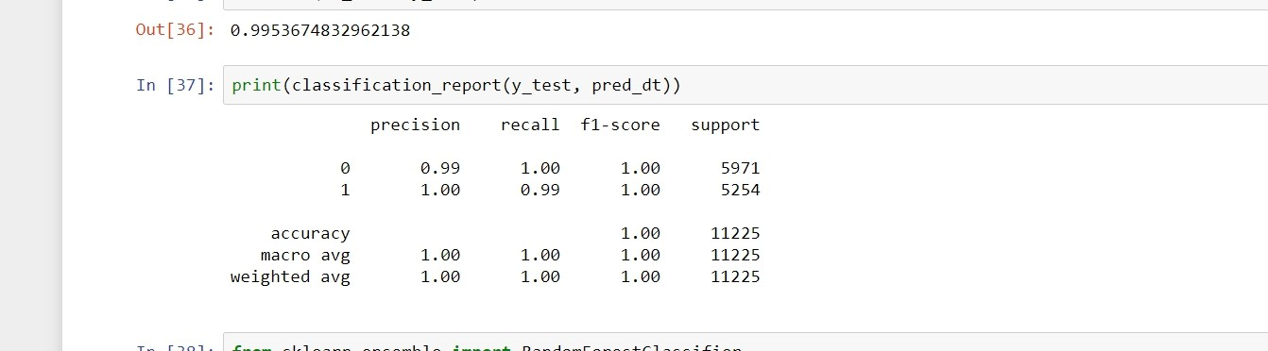

**Fig:5.18 .Accuracy of DecisionTree Classifier**

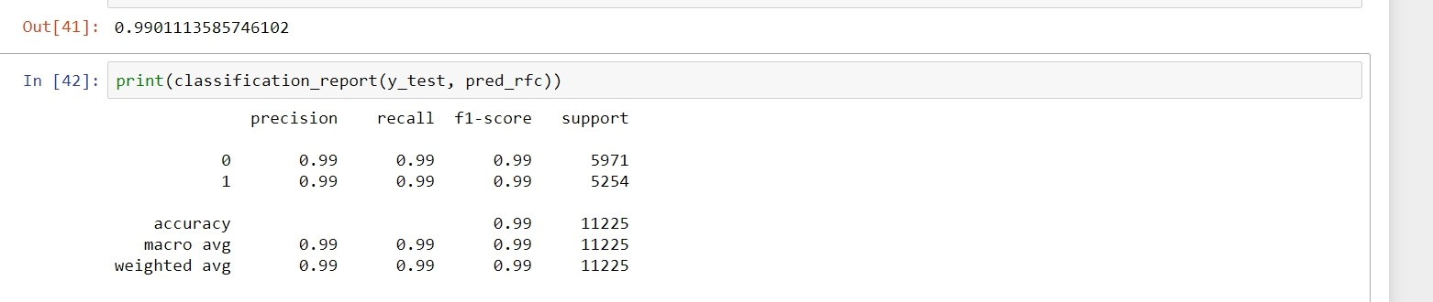

**Fig 5.19: Accuracy of Random Forest Classifier**

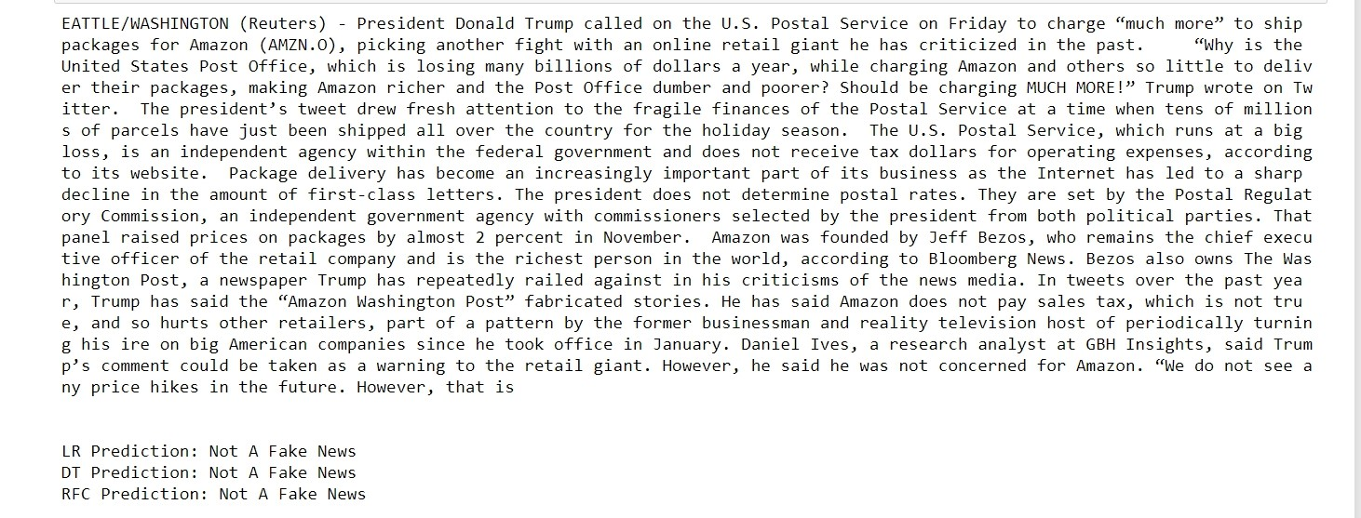

**Fig:5.20. Predicting Fake and Real News**

**6.CONCLUSION AND FUTURE SCOPE**

**6.1. CONCLUSION**

To implement Fake News Detection, various Machine Learning Techniques have to be used. The model is trained using an appropriate dataset and performance evaluation is also done using various performance measures. The best model, i.e., the model with highest accuracy is used to classify the news article. Here, the purpose of this project was to build a model that help us to recognize the language patterns that can be used to classify fake and real news with the help of ML (machine learning) techniques. The result show that Logistic Regression to detect Fake news has accuracy 98.82%. Two other more advance methods which are Decision Tree and Random Forest achieve the accuracy of 99.65% and 99.21%.

**6.2. FUTURE SCOPE**

Future work might want to explore how hybrid decision models consisting of both fact verification and data driven Machine Learning judgements can be integrated. In the future, the efficiency and accuracy of the prototype can be enhanced to a certain level, and also enhance the user interface of the proposed model. As future work, we plan to better study the combination between the feature extraction methods and the classifiers as we will be able to choose the text representation model that performs best with the classifier. Moreover, to achieve a higher accuracy, we will have to implement a more sophisticated algorithm which may use data mining technologies with big data, because creating a big dataset including more types of news articles with more class variables (labels) will help raising the accuracy score.

**REFERENCES**

1. Shloka Gilda, “Evaluating Machine Learning Algorithms for Fake News

Detection” ,2017 IEEE 15th Student Conference on Research and Development.

1. Kai Shu, Amy Sliva, Subang Wang, Jiliang Tang, and Huan Liu, “Fake News

Detection on Social Media: A Data Mining Perspective” arXiv:1708.01967v3 [cs.SI],

3 Sep 2017

1. M. Granik and V. Mesyura, “Fake news detection using naive Bayes classifier,” 2017 IEEE 1st Ukr. Conf. Electrical Comput. Eng. UKRCON 2017 - Proc., pp. 900– 903, 2017.
2. S. Gilda, “Evaluating machine learning algorithms for fake news detection,” IEEE Student Conf. Res. Dev. Inspiring Technol. Humanit. SCOReD 2017 - Proc., vol.

2018– January, pp. 110–115, 2018.

1. Parikh, S. B., & Atrey, P. K. (2018, April). Media-Rich Fake News Detection: A

Survey. In 2018 IEEE Conference on Multimedia Information Processing and

Retrieval (MIPR) (pp. 436-441). IEEE

1. Stahl, K. (2018). Fake News Detection in Social Media.
2. Aayush Ranjan, “Fake News Detection Using Machine Learning”, Department of Computer Science & Engineering Delhi Technological University, July 2018.
3. S. Gilda, “Evaluating machine learning algorithms for fake news detection,” IEEE Student Conf. Res. Dev. Inspiring Technol. Humanit. SCOReD 2017 - Proc., vol.

2018– January, pp. 110–115, 2018.

1. Aayush Ranjan, “Fake News Detection Using Machine Learning”, Department of

Computer Science & Engineering Delhi Technological University, July 2018